Lab 8 Placeholder
I completed memory management tasks including virtual memory, paging, page tables, and TLB simulation using C#. I calculated virtual/physical page numbers and offsets, determined page frame values, and simulated TLB hits/misses with hit ratio tracking. I also worked on memory interfacing using decoders and combined address patterns to read/write specific memory locations.

Task 1:
(i) Virtual Pages and Bytes per Page
- Virtual pages: With a 4-bit virtual page number (VPN), the number of virtual pages is $2^{4}=16$.
- Bytes per page: With an 8-bit offset, the page size is $2^{8}=256$ bytes.
(ii) Address Translation Example
Next figure illustrates 16 virtual pages mapped to 8 physical pages. A load instruction references the virtual address 0x2C8. We need to determine the VPN, offset, and the corresponding physical page number (PPN).
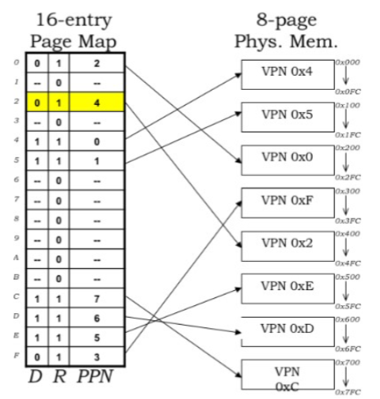
Step 1 – Convert to binary
$$0x2C8=0010 1100 {1000}_{2}$$
- 0x2 → 0010
- 0xC → 1100
- 0x8 → 1000
Step 2 – Extract VPN and offset
- VPN: The top 4 bits 0010 → VPN = 0x2
- Offset: The bottom 8 bits 1100\,1000 → Offset = 0xC8
Step 3 – Find PPN
Using the page map in Figure 40, VPN 0x2 maps to PPN 0x4.

Task 2
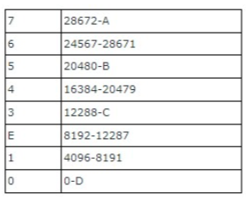
Each page frame is 4096 bytes (4 KB).
The end address is calculated as:
$$\text{End address}=\text{Start }\text{address}+4095$$
- D: Frame 0 starts at 0
→ End = $0+4095=4095$
- C: Frame 3 starts at 12288
→ End = $12288+4095=16383$
- B: Frame 5 starts at 20480
→ End = $20480+4095=24575$
- A: Frame 7 starts at 28672
→ End = $28672+4095=32767$
Task 3
a What is the virtual page being referenced?
From Figure 41, the first 20 bits of the virtual address are:
00000000000000000001
In decimal: 1
The referenced virtual page is 1.

b Page frame value (in both binary and denary)
For Virtual Page Number 1, the page table indicates:
Present/Absent bit = 1 (page is present)
Page frame bits = 001
Thus, the page frame value is:
Binary: 001
Decimal: 1

c Construct the physical address
The physical address is formed by concatenating:
The page frame bits from 2.b (001)
The offset bits (the last 12 bits of the virtual address)
Resulting physical address:
001100001011011
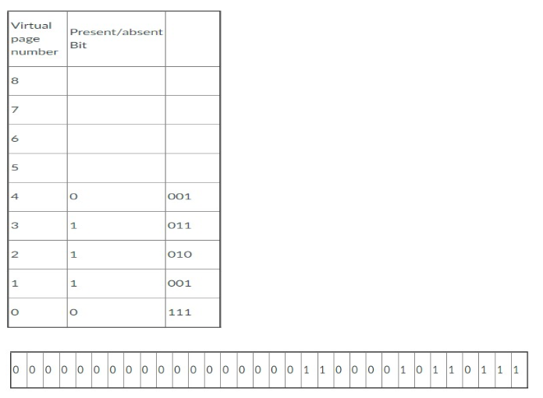

Task 4
(i) Pages in physical memory:
$$\frac{\text{Physical Memory Size}}{\text{Page Size}}=\frac{2^{24}\text{ Bytes}}{2^{10}\text{ Bytes/page}}=2^{14}\text{ pages}=16,384\text{ pages}$$
(ii) Entries in the page table:
$$\frac{\text{Virtual Memory Size}}{\text{Page Size}}=\frac{2^{32}\text{ Bytes}}{2^{10}\text{ Bytes/page}}=2^{22}\text{ entries}=4,194,304\text{ entries}$$
(iii) Bits per entry in page table:
$$\text{PPN bits}+\text{Control bits}=14\text{ bits}+2\text{ bits}=16\text{ bits (or 2 bytes)}$$
(iv) Pages occupied by page table:
$$\text{Total Page Table Size}=2^{22}×16\text{ bits/entry}=2^{23}\text{ bytes} \\ \frac{2^{23}\text{ Bytes}}{2^{10}\text{ Bytes/page}}=2^{13}\text{ pages}=8,192\text{ pages}$$
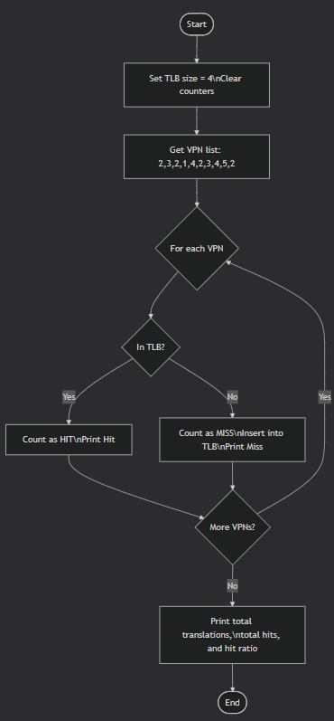
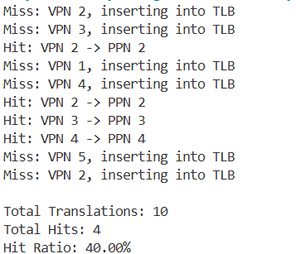

Task 5
5.1 Address Decoding
The memory contains 14 locations (indices 0 to D in hexadecimal).
To address all locations:
$$\text{Address bits}=⌈{log⁡}_{2}(14)⌉=4\text{ bits}$$
since $2^{4}=16≥14$.
Decoder Configuration
- Maps 4-bit address inputs to 16 chip select lines (CS0 – CS15)
- Only 14 outputs (CS0 – CS13) are used
Data Path
Each memory location stores 4 hexadecimal digits:
$$\text{Data width}=4\text{ digits}×4\text{ bits/digit}=16\text{ bits}$$
Control Signals
- WR – Active-low write enable
- RD – Active-low read enable
- EN – Global memory enable

5.2
- Pattern format (active HIGH): WR RD EN A3 A2 A1 A0
- Target: Read content FEAD
- Location: FEAD is at Index A
- Index A (hex) → Binary 1010 for A3 A2 A1 A0
Setting bits for "Read Index A":
- WR = 0
- RD = 1
- EN = 1
- A3 A2 A1 A0 = 1 0 1 0
Combined address (WR RD EN A3 A2 A1 A0):
$$0111010$$
Hexadecimal result: 0x3A

